FAQs ON DANGEROUS GOODS
Index
Q: What are dangerous goods? 1
Q: A number of terms are used with dangerous goods. What do they mean? 2
Q: What are the different classes of dangerous goods? 2
Q: What are Goods too Dangerous to be Transported? 4
Q: What are Combustible Liquids? 4
Q: How can I determine whether chemicals supplied to me are dangerous goods or combustible liquids? 4
Q: What are stated dangerous goods and stated combustible liquids? 5
Q: What are fire-risk dangerous goods? 5
Q: When are combustible liquids stored ‘with' fire-risk dangerous goods? 5
Q: What is the difference between 'hazardous materials', 'dangerous goods' and 'hazardous substances'? 6
Q: What is an Emergency Information Panel (EIP)? 6
Q: What are the dangerous goods classifications of fuels? 7
Q: How can I determine if different dangerous goods stored together are compatible? 7

Q: What are dangerous goods?
A: Dangerous goods are substances or articles that are potentially dangerous to people, property and the environment. They include materials that are:
- explosive;
- flammable;
- spontaneously combustible (burst into flames without being lit);
- water reactive (produce flammable or toxic gases if mixed with water);
- oxidising (help a fire to burn more fiercely);
- toxic (poisonous); and
- corrosive.
Some examples of dangerous goods include:
- petroleum;
- pool chlorination products;
- liquefied petroleum gas (LPG);
- ammonium nitrate fertiliser; and
- articles that contain dangerous goods (e.g. car batteries).

Q: A number of terms are used with dangerous goods. What do they mean?
A: The following terms are used to identify dangerous goods and to give information about their hazards:
UN Number: A four-digit number assigned by the United Nations to to identify dangerous goods;
Proper Shipping name: A standard name given to dangeorus goods for transport purposes;
Class: Dangerous goods are grouped into classes according to the most significant hazard presented by the goods. There are nine classes (numbered 1 - 9), some having sub-classes
Subsidiary risk (sub-risk): Where dangerous goods present more than oner hazard, the less significant hazards are termed “sub-risk”;
Packing group (PG): The degree of danger presented by dangerous goods is signified by Roman numerals as follows:
Packing Group I - high danger
Packing Group II - medium danger
Packing Group III - low danger
For a full and formal discussion on dangerous goods terminology, refer to the “Australian Dangerous Goods Code”.

Q: What are the different classes of dangerous goods?
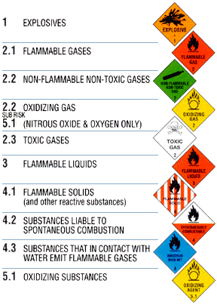
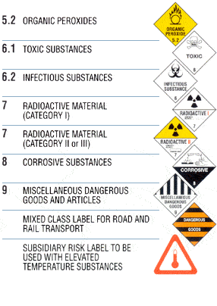
A: Dangerous goods are grouped into different classes according to the most significant risk presented by the goods. There are nine classes (numbered 1 - 9), some having sub-classes. Each class or sub-class has a unique identifying label (commonly known as a ‘diamond'), as shown below.

Class 1 | Explosive substances or articles used to produce explosions  Information on the classification of Class 1 Explosives is included in the Australian Explosives Code.
Class 2.1 | Flammable gas  Gases that can ignite in air on contact with a source of ignition.
Class 2.2 | Non-flammable, non-toxic gas  Gases that are non-flammable but may cause suffocation.
Class 2.2  sub-risk 5.1 | Oxidising gases  Gases that are non-flammable and non-toxic but which contribute to combustion, such as oxygen and nitrous oxide.
Class 2.3 | Toxic gas  Gases likely to cause death or serious injury if inhaled.
Class 3 | Flammable liquids  Liquids, the vapours of which can ignite in air on contact with a source of ignition.
Class 4.1 | Flammable solids  Substances that are easily ignited by external sources, such as sparks and flames.
Class 4.2 | Substances liable to spontaneous combustion  Substances likely to heat spontaneously and catch fire.
Class 4.3 | Substances that in contact with water emit flammable gases  Substances that produce dangerous quantities of flammable gas when in contact with water. Heat from this reaction may cause these gases to spontaneously ignite.
Class 5.1 | Oxidising substances  Substances that are not necessarily combustible by themselves, but which produce oxygen, which increases the risk and intensity of fire in other materials with which they may come into contact.
Class 5.2 | Organic peroxides  Organic substances containing bivalent oxygen that are thermally unstable and likely to react dangerously with other substances.
Class 6.1 | Toxic substances  Substances likely to cause death or serious injury if swallowed, inhaled or brought into contact with the skin.
Class 6.2 | Infectious substances  Substances known or likely to contain micro-organisms which can cause disease. Further information is available from Queensland Health.
Class 7 | Radioactive material  Material for which the specific activity exceeds 70kBq/kg. Further information is available from Queensland Health Radiation Health Unit.
Class 8 | Corrosive substances  Solid and liquid substances that can severely damage living tissue or attack other materials such as metals.
Class 9 | Miscellaneous dangerous goods and articles  Substances and articles that present a danger, but are not covered by other classes.

When specific Dangerous Goods have more than one significant hazard, they are assigned a Class on the basis of the most significant hazard, and are assigned one or more subsidiary risks (‘sub-risks’) according to the other hazards.
Information on the classification of dangerous goods may be gained from the Australian Dangerous Goods Code (ADG Code) – available from Australian Government bookshops.

Q: What are Goods too Dangerous to be Transported?
A: These goods are considered too dangerous to transport because of their instability and potential to react violently.

Q: What are Combustible Liquids?
A: Combustible liquids are liquids that burn, but are more difficult to ignite than flammable liquids. They have a flashpoint greater than 60.5°C and are not classified as Dangerous Goods (whereas liquids with a lower flashpoint are Dangerous Goods Class 3 – [flammable liquids]). Combustible liquids are divided into two classes according to flashpoint, as follows:
- C1 – flashpoint not greater than 150°C; and
- C2 – flashpoint greater than 150°C.
Information on the classification of flammable and combustible liquids is available in Australian Standard AS 1940 ‘The storage and handling of flammable and combustible liquids’. See American Petroleum Institute for further details.

Q: How can I determine whether chemicals supplied to me are dangerous goods or combustible liquids?
A: For dangerous goods, this information should be available from the label on the container or from the Material Safety Data Sheet (MSDS).
In all cases, your supplier should be able to give you the information.
The information should tell you the classification information, that is, the class and packing group (PG) of dangerous goods and the type of combustible liquids (C1 or C2).

Q: What are stated dangerous goods and stated combustible liquids?
A: ‘Stated dangerous goods’ are:
- Dangerous goods of Classes 2, 3, 4, 5, 6.1, 8 and 9;
- Goods too dangerous to be transported (GTDTBT).
‘Stated combustible liquids’ are:
- C1 combustible liquids; and
- C2 combustible liquids stored with fire risk dangerous goods.

Q: What are fire-risk dangerous goods?
A: Fire risk dangerous goods are dangerous goods of Class or sub-risk 2.1, 3, 4.1, 4.2, 4.3, 5.1 or 5.2. These materials may contribute to the risk of fire either by adding to the fuel load or by increasing the ease and rate of combustion.

Q: When are combustible liquids stored ‘with' fire-risk dangerous goods?
A: If you have both combustible liquids and fire-risk dangerous goods at your premises, there exists:
- a fuel load represented by the total of all the flammable or combustible materials present; and/or
- a risk of ignition of the flammable or combustible materials by oxidising agents.
- Are the combustible liquids stored ‘with' the fire-risk dangerous goods, or not?
- To answer this, you should consider the following:
- Is there a potential for interaction between the combustible liquids and the fire-risk dangerous goods?
- If the fire-risk dangerous goods became involved in a fire, could that fire spread to the combustible liquids (or vice-versa)?
- Could the Class 5 oxidising agents and the combustible liquids come into contact and start a fire?
If the answer to any of these questions in ‘Yes', then you have combustible liquids stored with fire-risk dangerous goods.
While you may have both combustible liquids and fire-risk dangerous goods at your premises, if they are segregated from each other so as to avoid the potential of interaction between them, it is appropriate to answer ‘No' to the questions above.
Segregation of materials may be achieved by distance or barriers or both. Australian Standards dealing with storage of dangerous goods usually provide information about appropriate separation distances or barriers.
To answer these questions adequately, you may need to have conducted a thorough hazard identification process for the premises.

Q: What is the difference between 'hazardous materials', 'dangerous goods' and 'hazardous substances'?
A: ‘Hazardous materials’ is an umbrella term used to describe any substance that, because of its chemical, physical or biological properties, can cause harm to people, property or the environment. It is a term that collectively describes substances which are classified according to the hazard they present, including but not limited to ‘dangerous goods’, ‘combustible liquids’, and ‘hazardous substances’.
Dangerous goods and hazardous substances are classified according to different criteria.
Dangerous goods are classified on the basis of immediate physical or chemical effects such as fire, explosion, corrosion and poisoning that may affect property, people or the environment (e.g. petrol, pool chlorine, and some pesticides).
Hazardous substances are classified only on the basis of health effects - both medium and long term - particularly in relation to workplaces.
Many materials are both dangerous goods and hazardous substances.
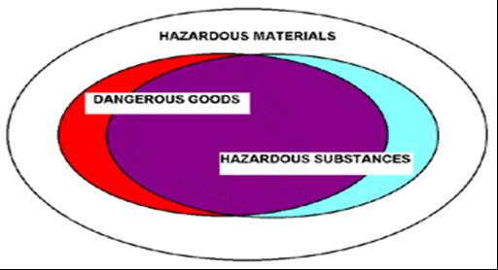

Q: What is an Emergency Information Panel (EIP)?
A: An EIP is a placard (sign) of specified format used to identify dangerous goods when transported in tanks. A modified EIP is required as a placard for tanks that store dangerous goods.
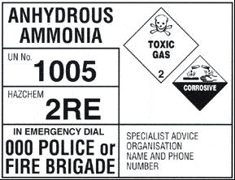

Q: What are the dangerous goods classifications of fuels?
A: The table below shows the typical classification of fuels as dangerous goods or combustible liquids. This information should be used when completing the notification form.
Petrol including grades such as:  - Unleaded ULP  - Lead Replacement LRP  - Super  - Premium | Class 3 PG II
Kerosene | Class 3 PG III
Diesel fuel | C1 Combustible Liquid
Fuel Oils and heating Oils | C1 Combustible liquid
Motor oil | C2 Combustible liquid
Waste oil | C2 Combustible liquid
LPG (Liquefied Petroleum Gas) | Class 2.1 (PG not applicable)
 | PG = Packing Group
If you are unsure of a fuel’s classification, consult the SHOC Card, the supplier and the Material Safety Data Sheet (MSDS) for the product.

Q: How can I determine if different dangerous goods stored together are compatible?
A: Two or more dangerous goods are deemed compatible if their interaction does not result in a reaction that may give rise to a fire, explosion, harmful reaction, or the evolution of flammable, toxic, or corrosive vapours. If goods are not compatible then they must not be stored together in a manner that will allow them to come into contact.
Compatibility charts can be used as an aid in determining if two classes of dangerous goods are compatible. The IATA and IMDG Codes contain a matrix for “Segregation of dangerous goods”. If the dangerous goods are deemed to be incompatible then measures need to be taken to segregate the incompatible goods.

